# AWS Certified Cloud Practitioner 2020

* this is the easiest exam
* Get at least certified associate architect

### **Exam Details**



Format  
65 questions; either multiple choice or multiple response



Type  
Foundational



Delivery Method  
Testing center or online proctored exam



Time  
90 minutes to complete the exam



Cost  
100 USD (Practice Exam: 20 USD)

**6 Advantages of Cloud Computing**

1. Trade Capital Expenses for Variable Expenses – pay only when you consume computing resources and pay only for how much you consume
2. Benefit from massive economies of scale
3. Stop guessing about capacity – scale business needs with no long term contracts
4. Increase speed and agility – ex: serverless architecture – scales infinitely with demand
5. Stop spending money running and maintaining data centers
6. Go global in minutes – easily deploy applications in multiple regions around the world

**3 Types of Cloud Computing:**

1. Infrastructure as a Service (IAAS) - ex: EC2
2. Platform as a Service (PAAS) – ex: Elastic Bean Stalk
3. Software as a Service (SAAS) – ex: Gmail

**3 Types of Cloud Computing Deployments:**

1. Public Cloud – AWS, Azure, GCP
2. Hybrid – mixture of public and private
3. Private Cloud (on premise) – manage in datacenter – Openstack or Vmware

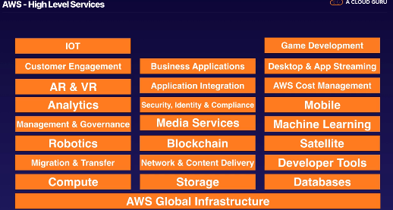  
**AWS High Level Services**

**AWS Cloud Practitioner Exam** 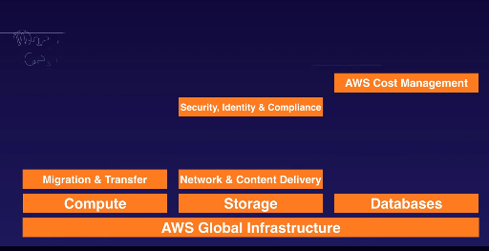

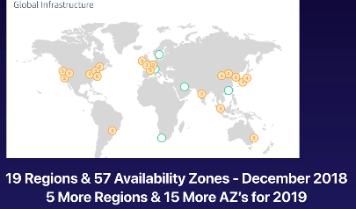

* Availability Zone ~ Data Center; spread out so if a natural disaster occurs, multiple AZ’s won’t be affected at the same time
* Region = geographical area made up of 2+ Availability Zones
* Edge Locations – endpoints used for caching content
  + More edge locations than regions
* Choosing the right AWS Region:
  + Data sovereignty laws
  + Latency to end users
  + AWS Services
    - US East 1 gets all services first

**Identity Access Management (IAM)**

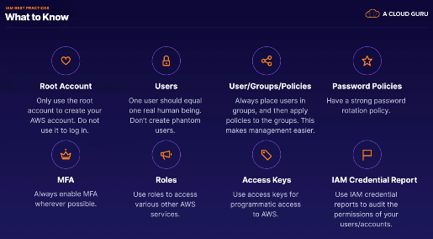

* Enable multifactor authentication (mfa) wherever possible for passwords

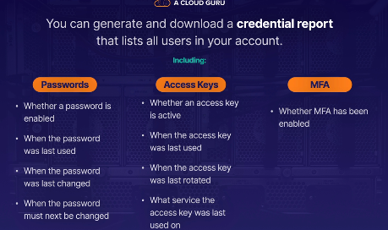

* Credential Report downloaded as CSV
  + Shows passwords, access keys, mfa

**Simple Storage Service: S3**

* One of the longest running been around since at least 2007
* S3 is a place to store flat files (ie: not changing files like videos, pictures, etc.)

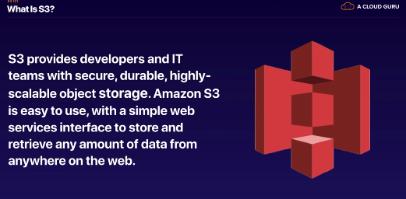

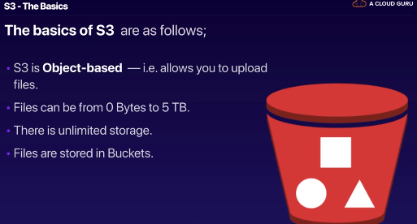

* Bucket = folder in cloud
* S3 is a universal namespace – bucket names must be unique globally
* Must be unique b/c creates a DNS address



* S3 is object based – objects = files
* S3 is key-value store
* Objects consist of:
  + Key – name of object
  + Value – sequence of bytes
  + Version ID
  + Metadata
  + Subresources: access control lists, torrent

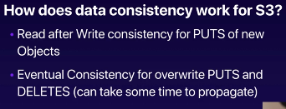 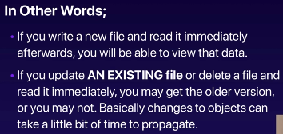

1. Read after Write consistency: you can immediately read file you place in S3
2. Eventual consistency: it takes a bit longer to access if you deleted a file

**Guarantees**

* 11 9’s durability: you won’t lose file uploaded into S3

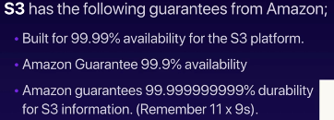

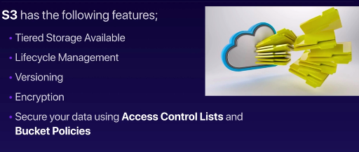

S3 Storage Classes:

1. S3 Standard
2. S3-IA: lower fee
3. S3 One Zone-IA:
4. S3 Intelligent Tiering – uses machine learning to move data across tiers
5. S3 Glacier – archival data
6. S3 Glacier Deep Archive – lowest storage
7. S3 Outposts

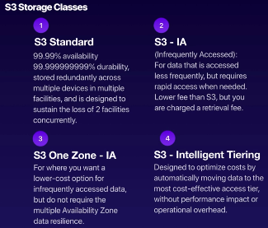

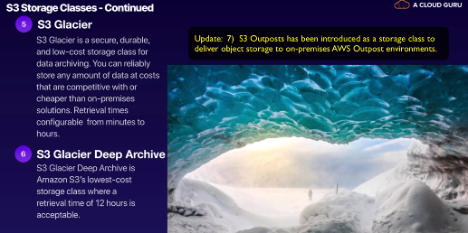

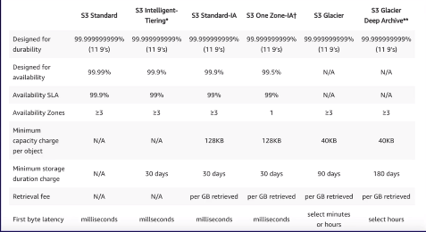

* First byte latency: how quickly you can access the first byte

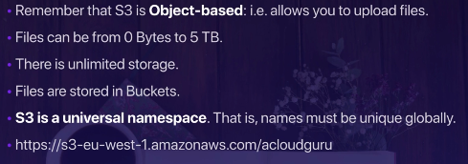

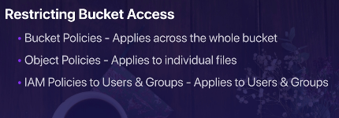

**CloudFront**

* Content delivery network (CDN) – system of distributed servers (network) that deliver webpages and other web content to users based on geographic locations of user, origin of webpage and content delivery server
* Make process of accessing websites faster

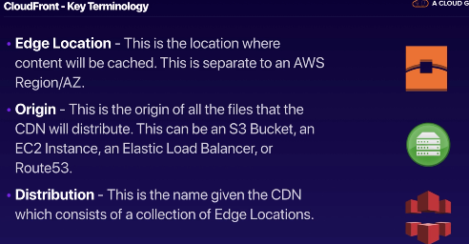

* TTL- time to live in edge location is about 48 hours
* 2 distributions:

1. Web Distribution – typically for websites; widely used
2. RTMP – media streaming; not commonly used anymore

**Elastic Compute Cloud (EC2)**\* EC2 is a compute based service. It’s a server in the cloud. It’s not serverless. Use a private key to connect to EC2.

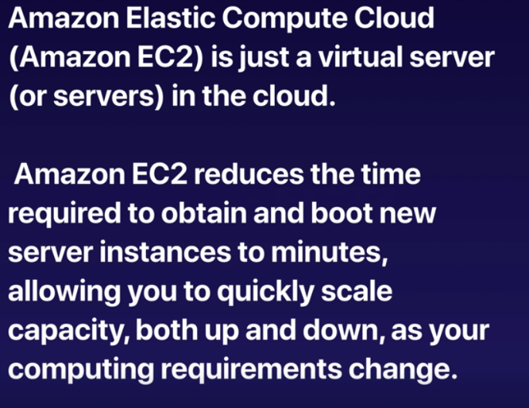

* Old way of renting out physical servers: deployment took anywhere from 2 weeks to 6 months
* EC2 creates virtual machines in minutes

**Pricing Models**

1. On Demand – pay fixed rate by hour (or second) with no commitment   
   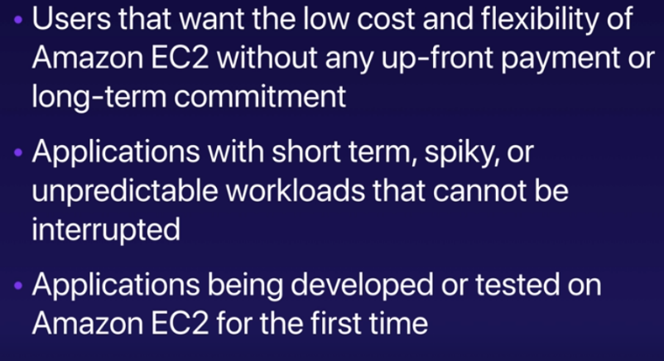
2. Reserved – 1 – 3 year term contract; capacity reservation, discount for hourly charge for an instance  
   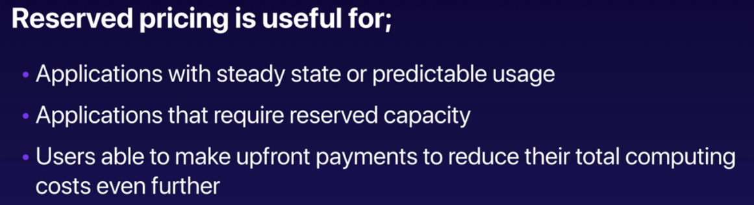

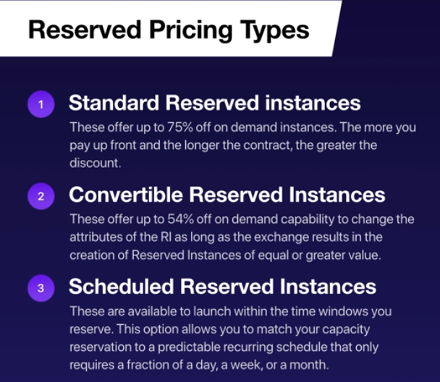

1. Spot – bid whatever price you want for instance capacity, providing greater savings if your applications have flexible start/end times; price moves around like stock market  
   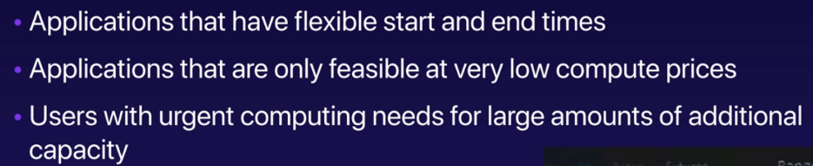

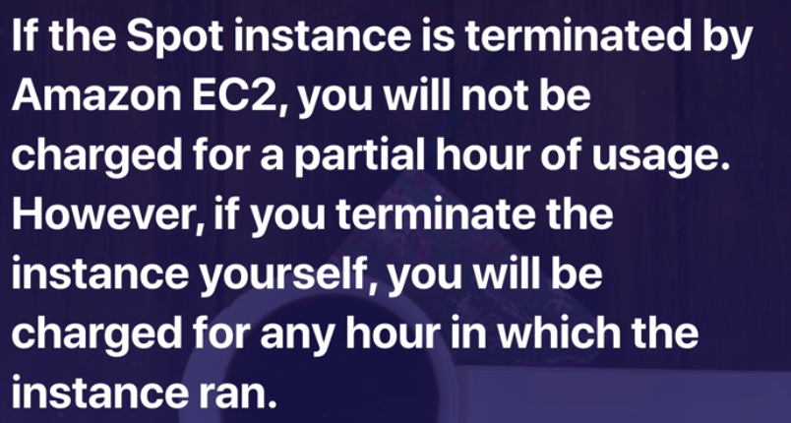

1. Dedicated Hosts – physical E2 server dedicated for use; dedicated hosts help reduce costs by allowing you to use your existing server-bound software licenses

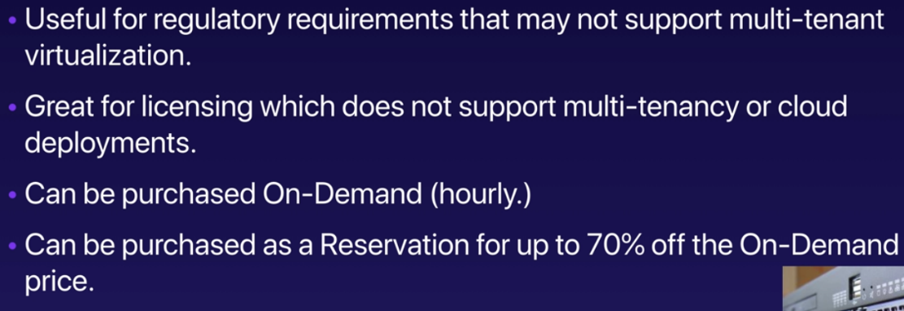

EC2 Instance types (family)

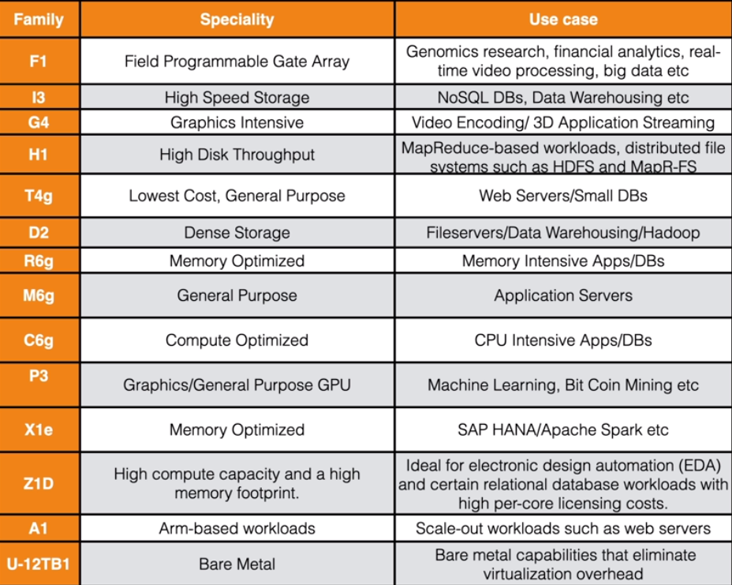

* Family = class instance

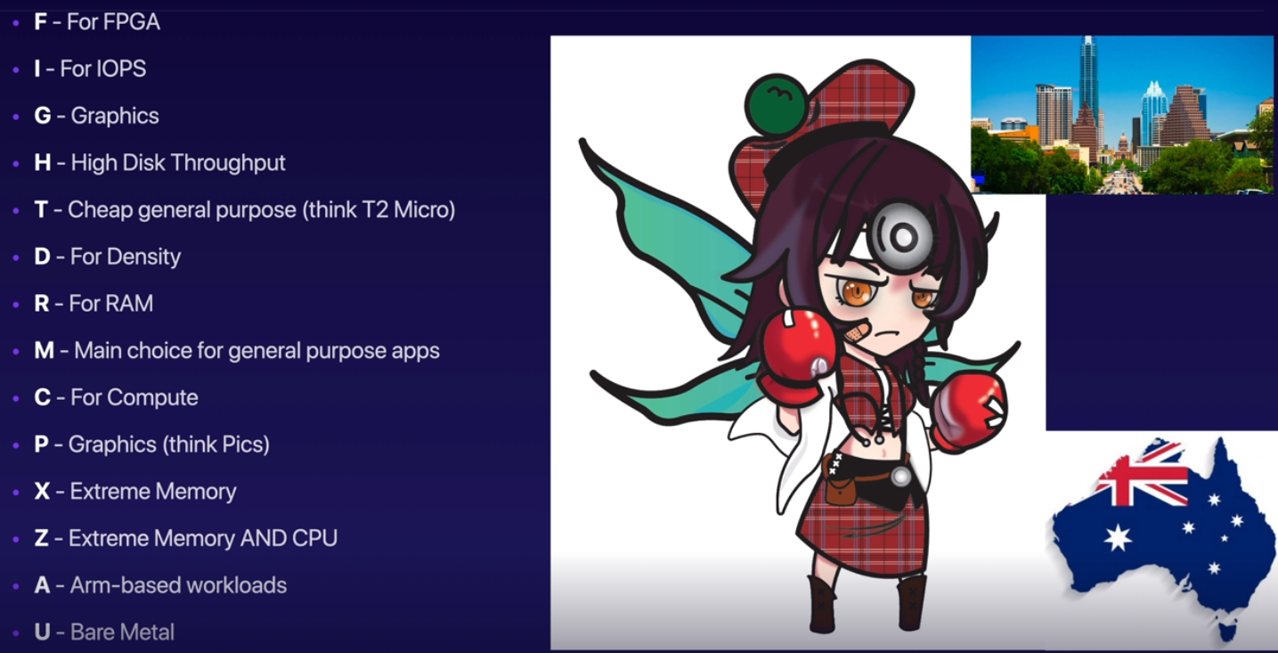

* Fight Dr. Mic Pixy in Austen or Australia

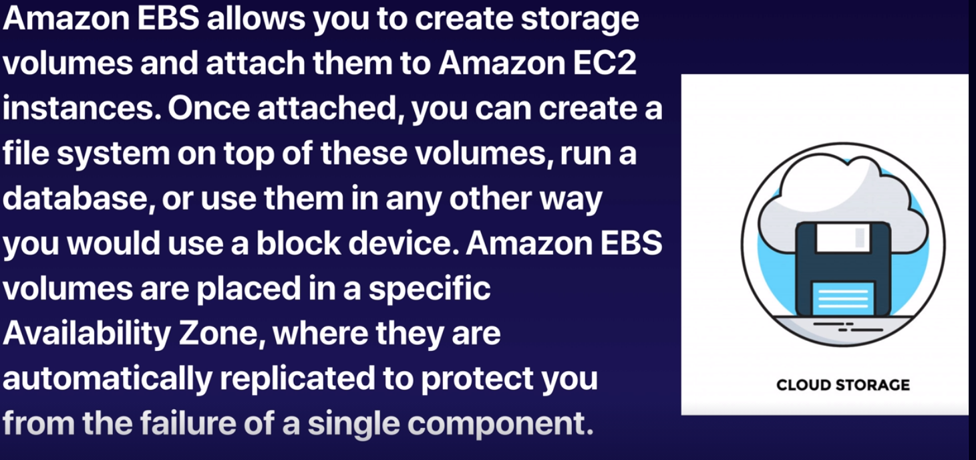

* EBS = virtual disk in the cloud

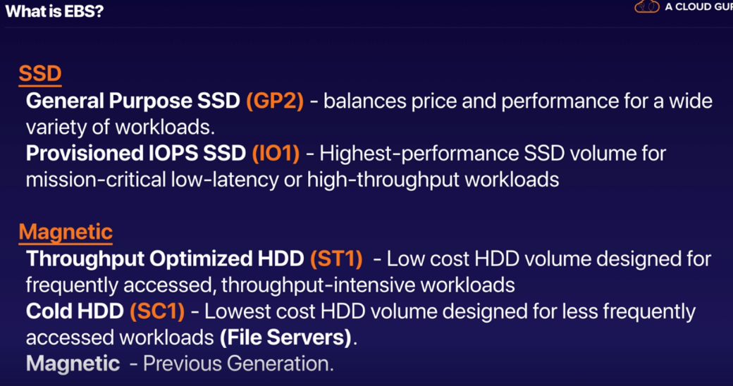

Lab: Launching an EC2 Instance in a Custom Virtual Private Cloud (VPC)

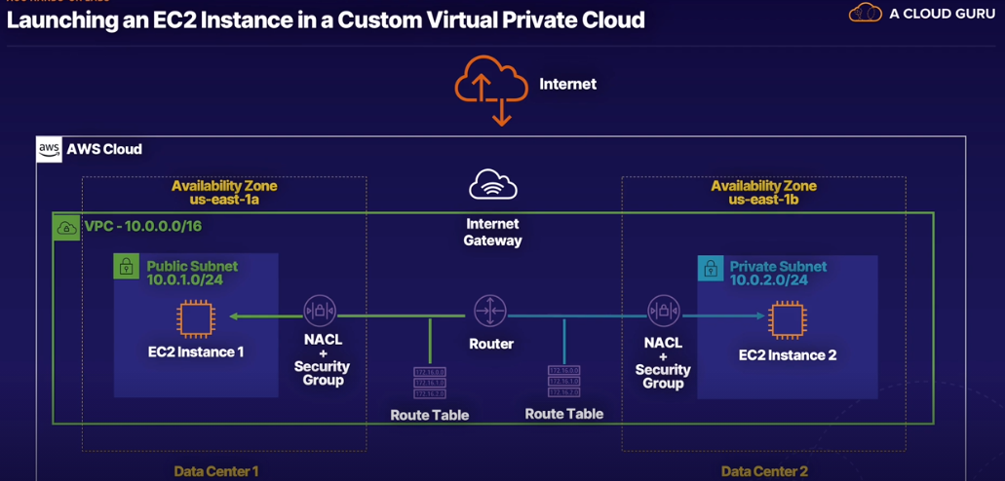

* VPC allows you to create a private network that isolated from other private networks in AWS to secure your resources

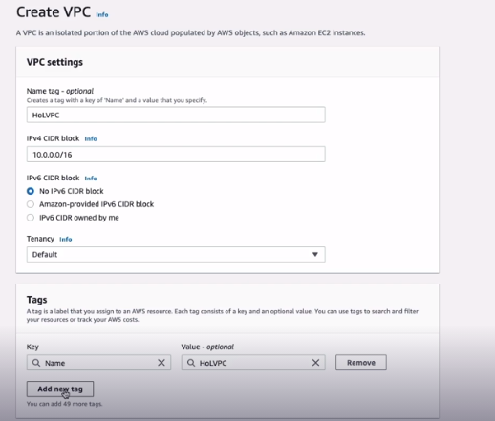

* Default = using shared hardware; other option is dedicated
* EC2 instances usually launched in subnet
* Each subnet must be in entirely 1 availability zone and cannot span zones

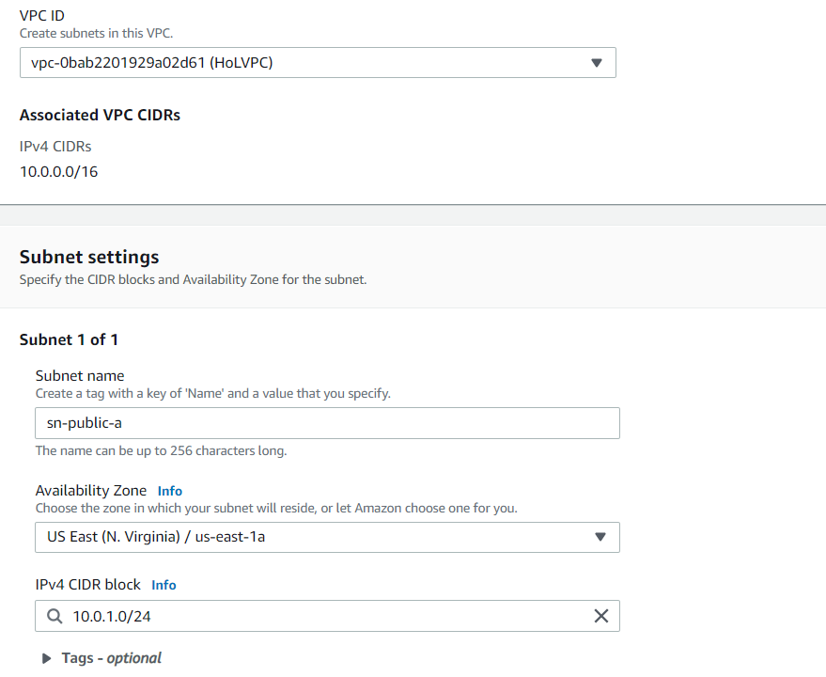

* ^ Created public (10.0.1) subnet
* All VPCs associated with one route table
* Each subnet must be associated with a route table
* Need to attach internet gateway to VPC

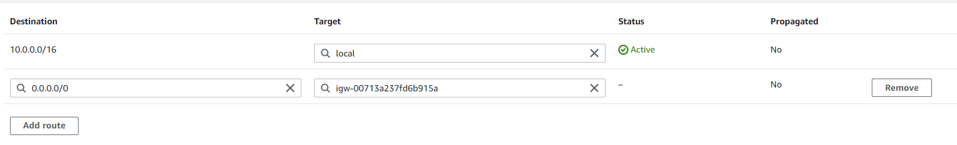0.0.0.0/0 represents public internet

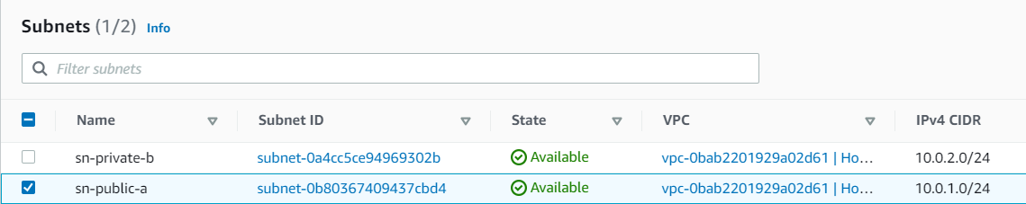

* Public subnet will allow traffic within it to access the internet
* No need to change configuration for private b/c subnets without route to internet are private – can’t reach internet but can reach other private subnets

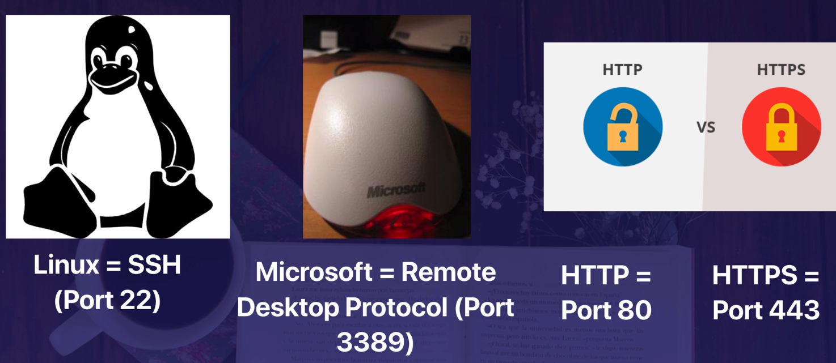

* Security groups = virtual firewalls in the cloud
* Always design for failure. Have one EC2 instance in each availability zone

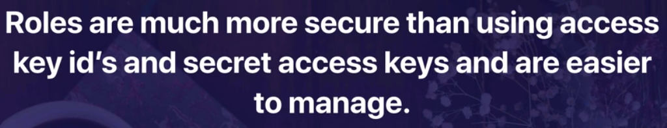

* Roles are easier to manager and more secure.
* Roles are universal. Made in IAM. Don’t need to specific what region they are in – similar to users

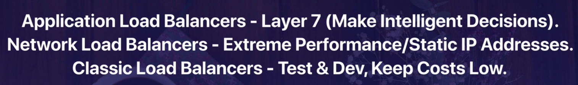

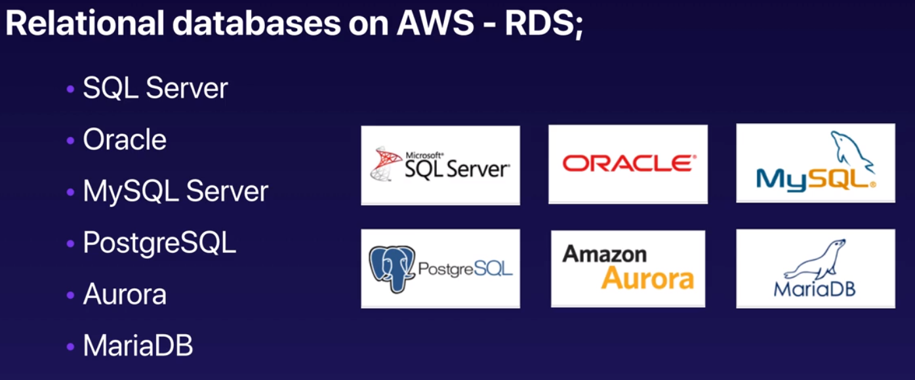

DynamoDB = Amazon’s Non-Relational Database (NoSQL)

2 Key Features:

1. Multiple Availability Zones – for disaster recovery
2. Read replicas – for performance; copies of production database

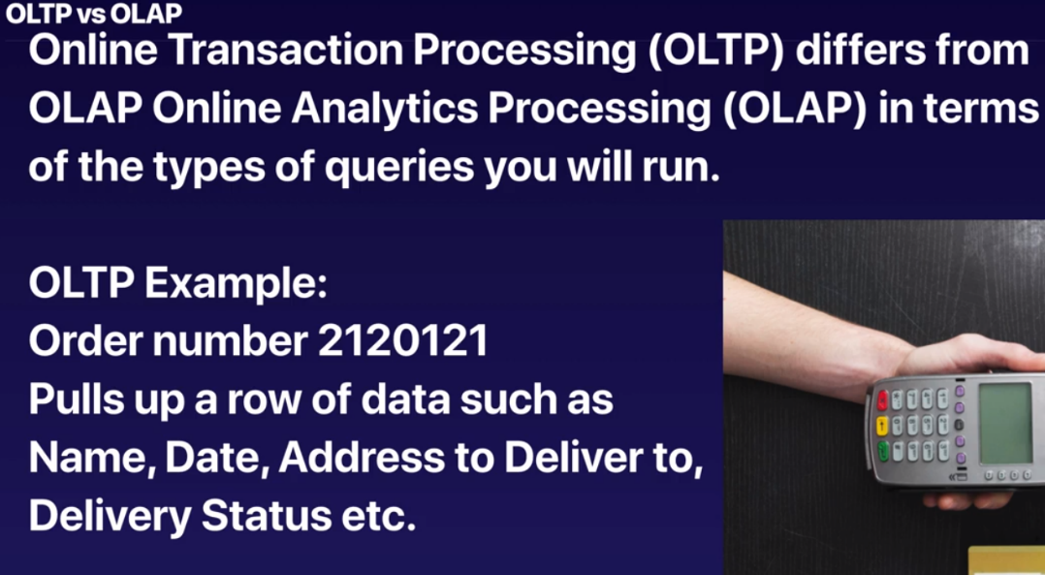

* Data Warehousing was invented to do OLAP – online analytics processing   
    
  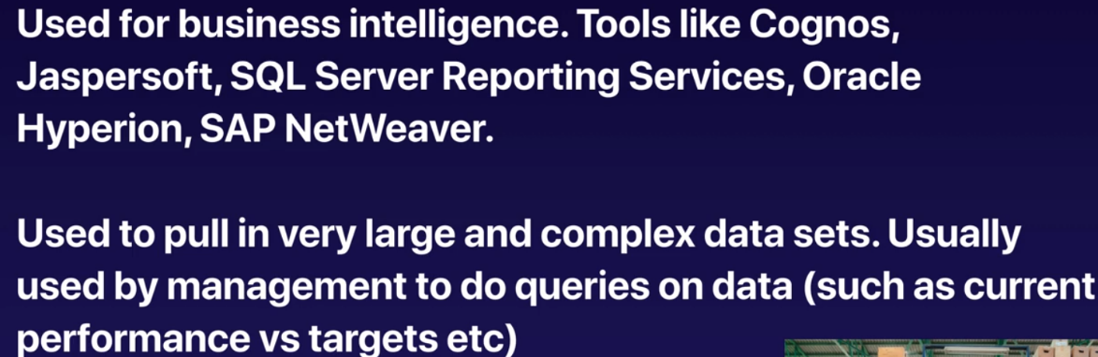
* **Amazon’s Data Warehouse Solution = Redshift** 
  + For business analytics

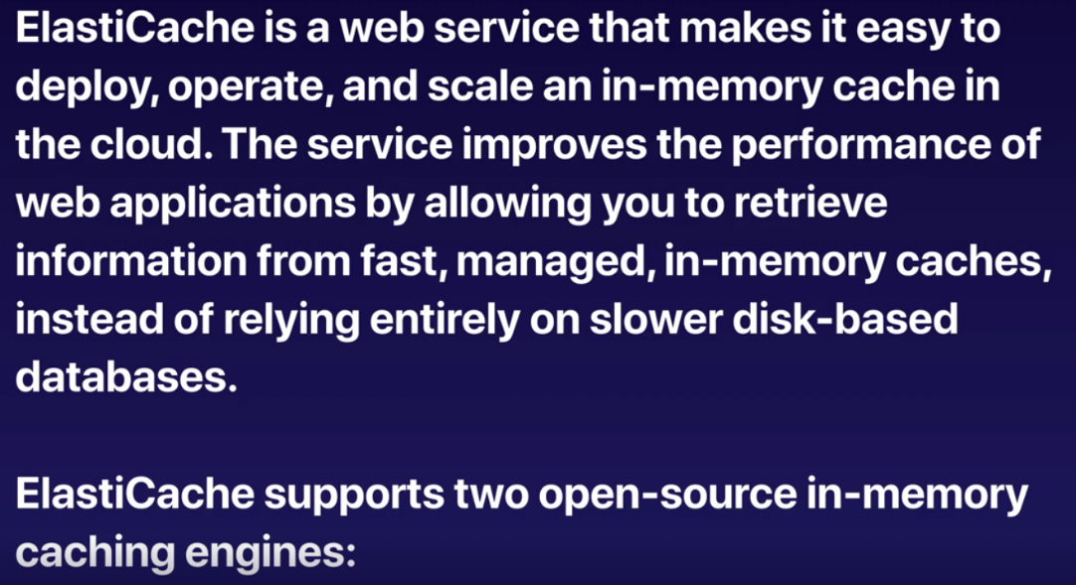

* **ElastiCache** – caching engine in cloud for most common queries; takes load off production databases because web queries will be pulling in from ElastiCach and not database
  + Speed up performance of existing databases (frequent identical queries)
* Caching engines:

1. Memchached
2. Redis

**Elastic Beanstalk**

* Way to deploy AWS resources without knowing all that much about AWS
* One button click automation to provision EC2 instances, security groups, application load balancers
* One of the compute serves

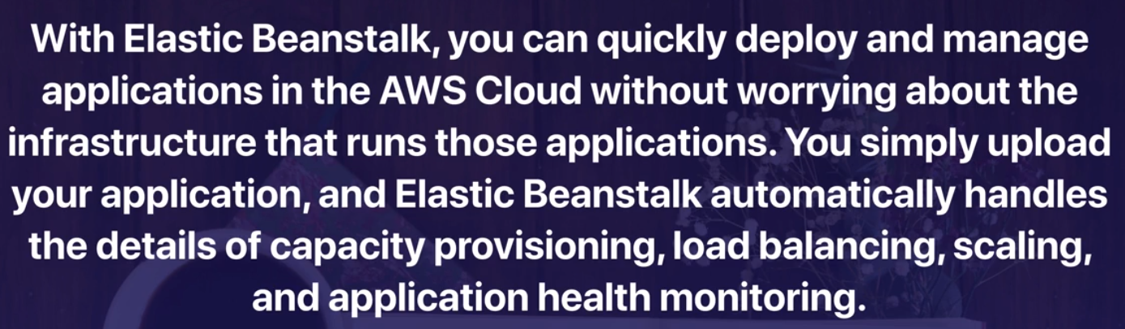

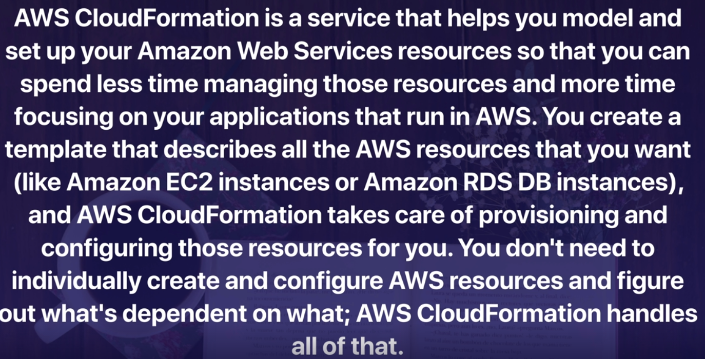

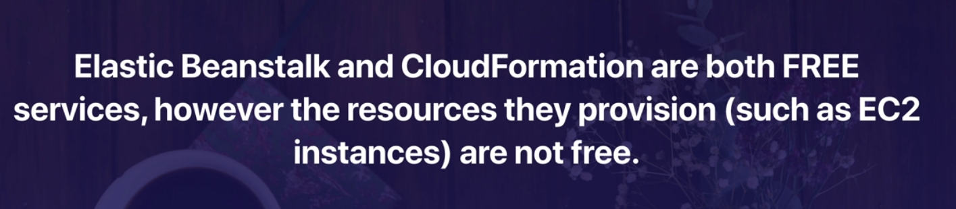

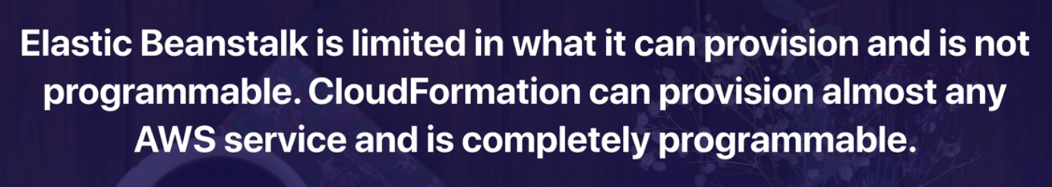

**Architecting for the Cloud – Best Practices**

* IT Assets as Provisioned Resources – no contract, pay as you go, much faster
* Global, Available and Scaleable Capacity
* Higher Level Managed Services
* Built-in Security – safer to have application hosted on AWS than internally on-prem
* Architecting for Cost – design environment on cloud to be cost efficient
* Operations on AWS – lift and shift of VMs to EC2; refactoring of databases and re-architecting application to make it cost efficient

Design Principles

* Scalability
  + Scale Up – increase RAM, CPU inside a virtual machine => ex: take T2 Micro instance and increase size
  + Scale Out – more common; add multiple VMs behind an elastic load balancer
    - Stateless Applications – Lambda: Alexa doesn’t remember what you say (forgets previous statements)
    - Distribute Load to Multiple Nodes
    - Stateless Components – more stateless components, the easier the application scales
    - Stateful Components – keep information, store in RDS database; user’s shopping cart and transactions
    - Implement Session Affinity – sticky sessions; cookie in user’s browser application stuck to particular EC2 instance with cookies
    - Disturbed Processing – elastic map reduce: cuts down time it takes to process massive amounts of data have difference EC2 instances that process large, complex jobs and data
    - Implement Distributed Processing – terminate environments without contracts, flexibility
* Instantiating Compute Resources
  + Bootstrapping – don’t have to manually configure EC2 instances every time
  + Golden Images – auto scaling and image of EC2 instance
  + Containers
  + Hybrid – combination of containers and EC2 instances
* Infrastructure As Code
  + CloudFormation – configures infrastructure and services quickly
* Automation
  + Serverless Management and Deployment – for deployment, using code pipeline
  + Infrastructure Management and Deployment
    - AWS Elastic Beanstalk
    - Amazon EC2 auto recovery
    - AWS Systems Manager
    - Auto scaling
  + Alarms and Events
    - Amazon CloudWatch alarms
    - Amazon CloudWatch Events – proactively respond to change in environment
    - AWS Lambda scheduled events
    - AWS Web Application Firewall (WAF) security automations – responds to security risks like SQL injections

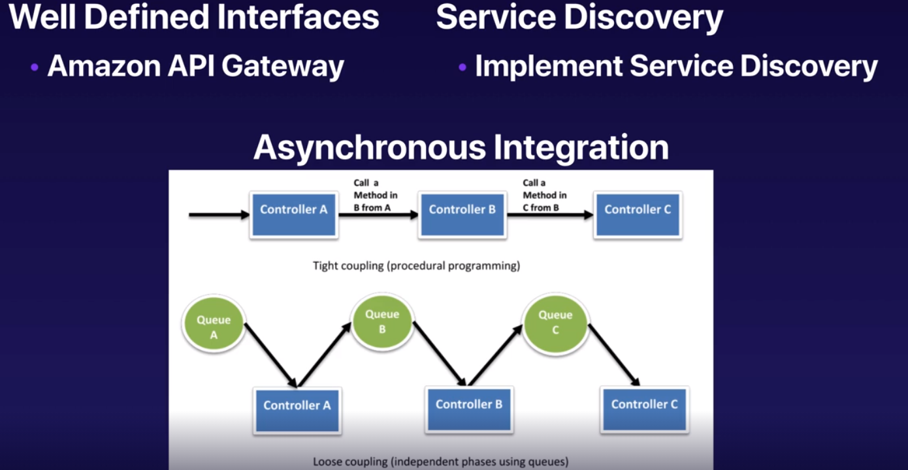

* Service discovery – one component of AWS automatically discovering another component
* Tight coupling – if one instance fails, another does
* Loosely coupling – more resilience if one instance fails (preferable for environment)

**Distributed Systems Best Practices**

* Ex: page on website doesn’t exist => way of telling user there is a failure and mechanism of informing administrators

**Services not Servers**

* Don’t rely on physical servers
* Move everything to serverless in next few years

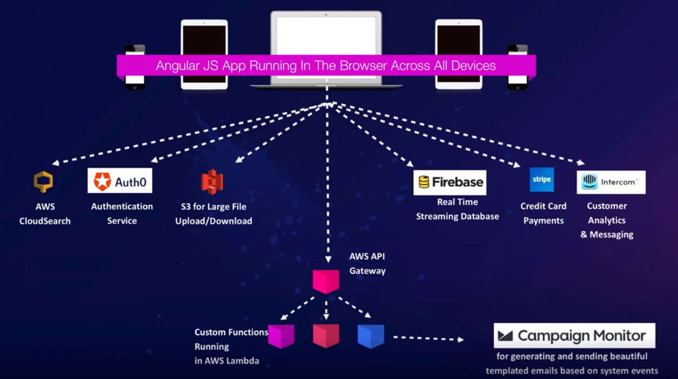

* Auth0: logging in with different application like FB & LinkedIn
* Mostly server less, no EC2 instance; compute bill about $400/mo

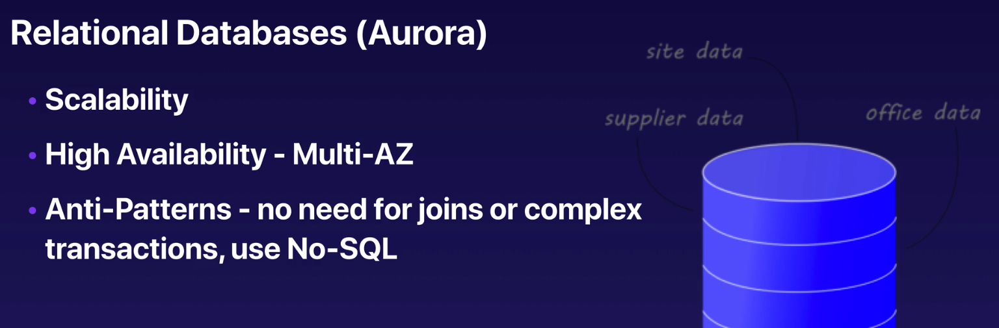

* Scalability – 6 copies of data spread across 3+ AZ

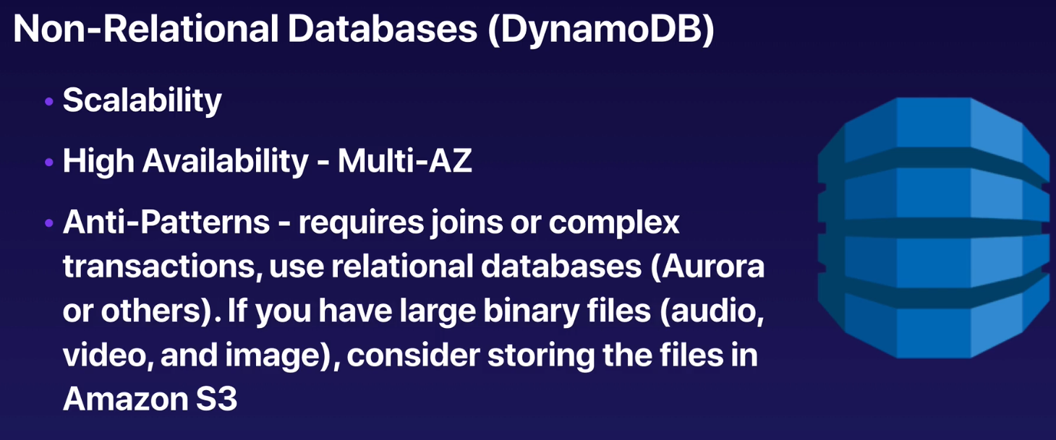

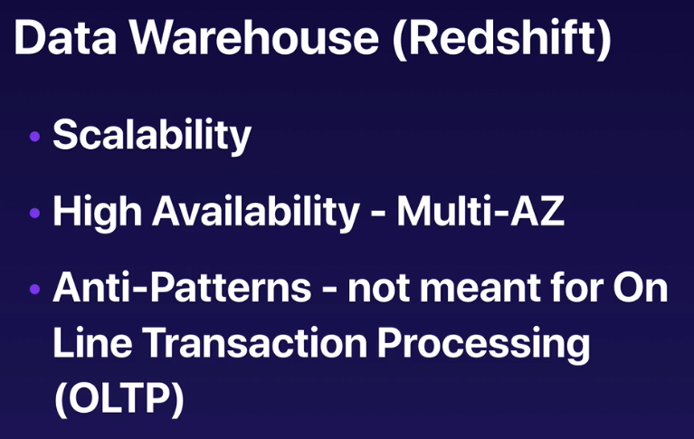

* Redshift for OLAP

**Search Services: Cloud Search & Amazon Elastic Search**

* Scalability
* High availability – spread across 2+ AZ

**Graph Databases: Amazon Neptune**

* Scalability
* High availability

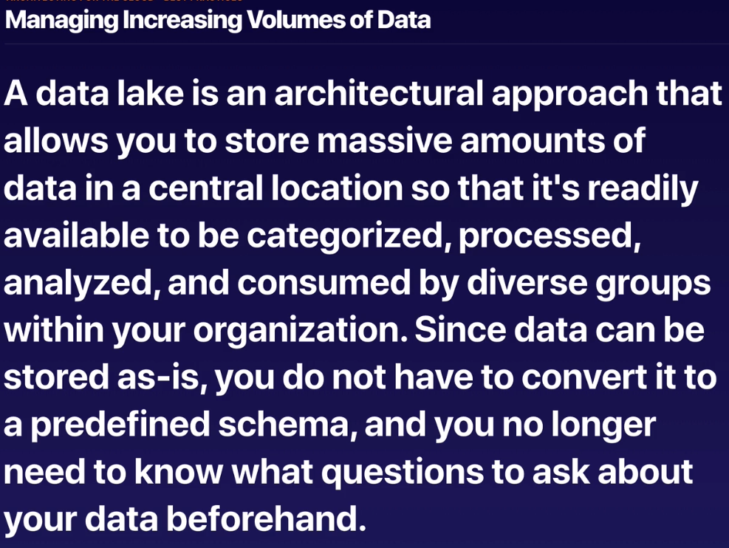

* S3 perfect place to store; use Athena to run SQL queries on db

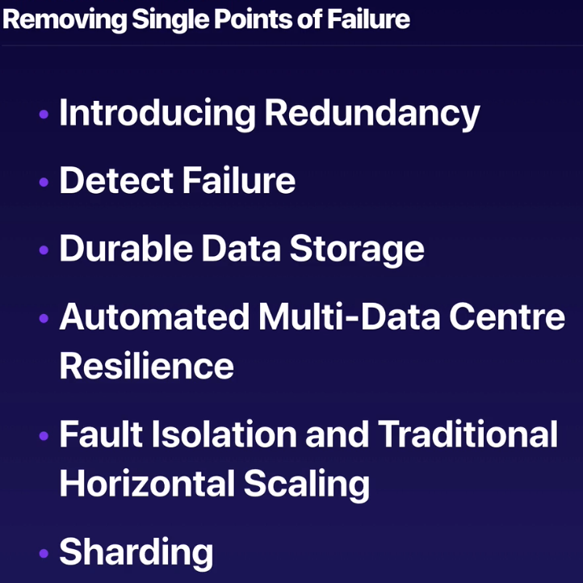

* Horizontal Scaling – scaling out; multiple EC2 instances behind elastic load balancer
* Vertical Scaling – scaling up

**Optimize for Cost**

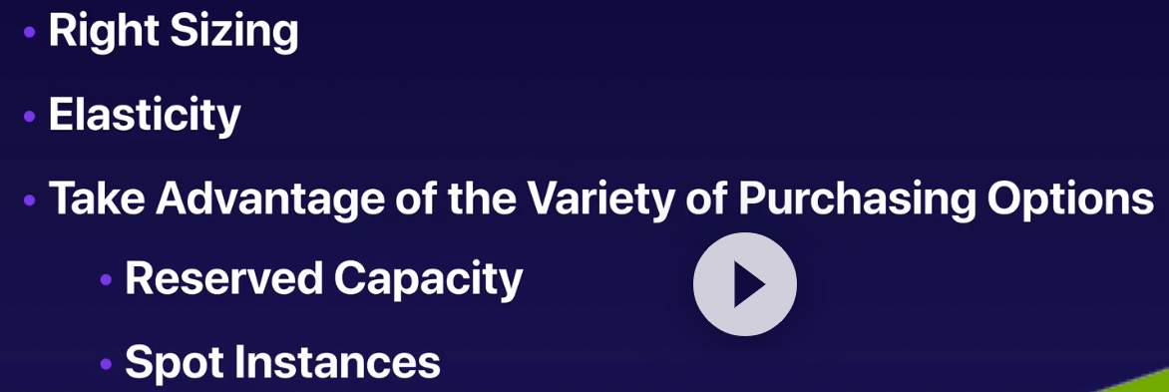

**Caching**

* Application Caching – Elastic cach
* Edge Caching – CDN networks like CloudFront

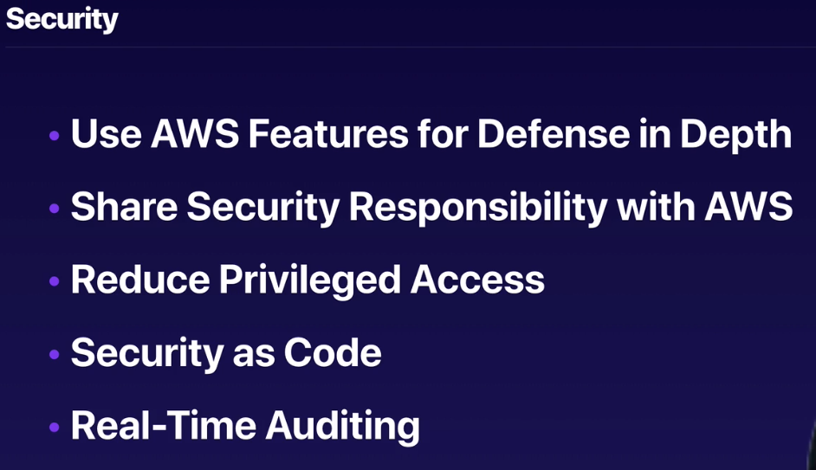

* Real-Time Auditing – AWS Cloud Trail

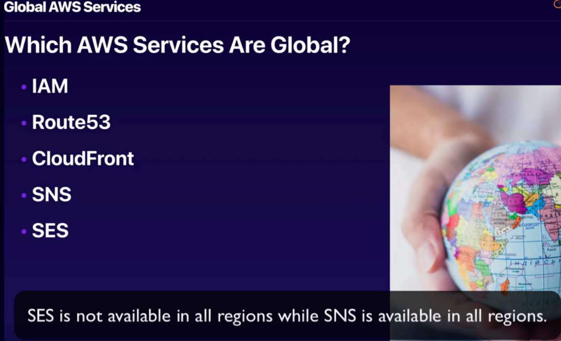

* Some Services give Global Views but are regional: S3

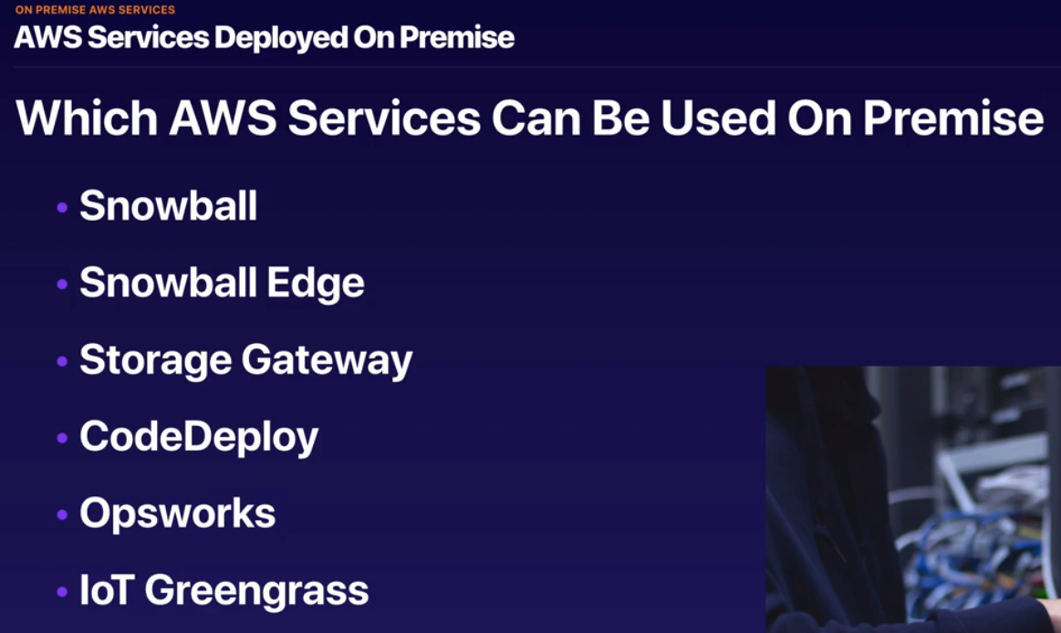

* Snowball (80 Terabytes storage) – gigantic disk to load up data faster and send back to Amazon to load up to S3; save time from 100 days to about a week
* Snowball Edge – computer with storage; deploy Lambda functions on premise; Boeing used for aircraft testing; used for where you can’t get AWS connectivity (ie: working in Antarctic) but need AWS resources
* Storage Gateway – cache files inside datacenters; physical and virtual
* CodeDeploy – used to deploy applications on premise
* Opsworks – similar to Elastic BeanStalk; uses shift for automated deployments – EC2 instances

**CloudWatch** – monitors performance; monitors most of AWS as well as applications that run on AWS

* Compute
  + EC2 Insances – monitors every 5 minutes by default
  + Autoscaling Groups
  + Elastic Load Balancers
  + Route53 Health
* Storage & Content Delivery
  + EBS Volumes
  + Storage Gateways
  + CloudFront
* Underling physical host: physical server CPU, Network, Disk, Status Check

**AWS Systems Manger Explained**

* Used to manage fleets of EC2 instances & virtual machines
* For managing multiple instances of EC2 (EC2 Fleet)
* Run command across all EC2 instances at once (ex: yum update) – used to install, patch, uninstall software

**Service Health Dashboard**

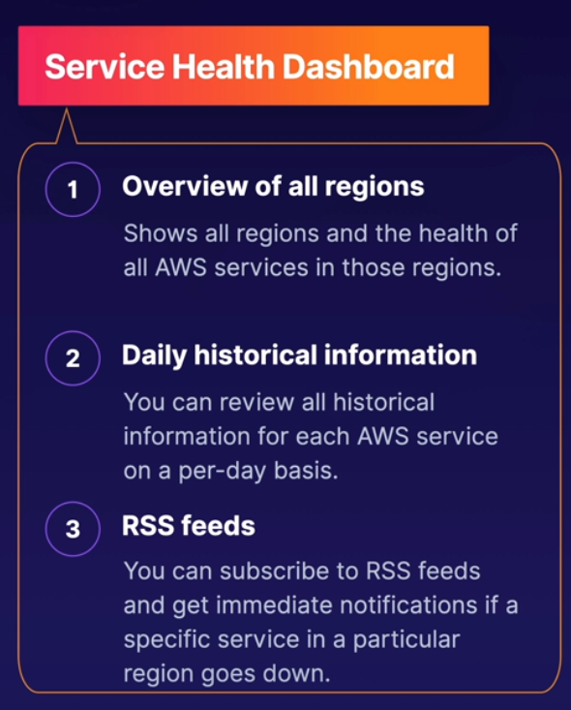

* For every AWS service in every region: if you have an outage and want to see it, use service health dashboard

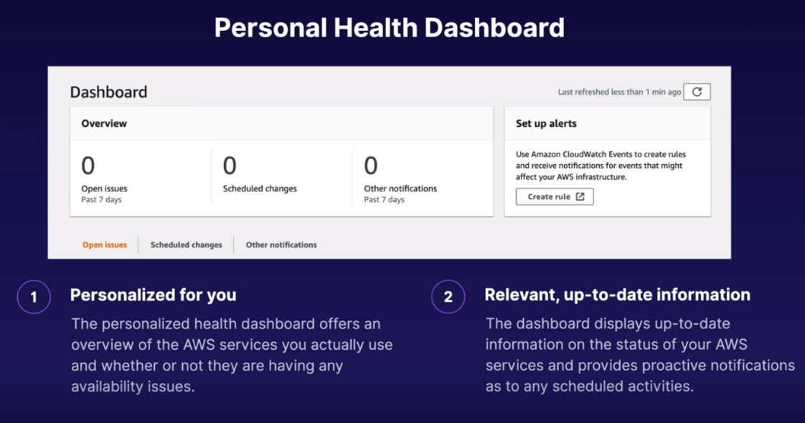

* Your specific applications and services
* Rules and alerts incase anything goes down

**3 Different Storage Options: S3, EBS and EFS**

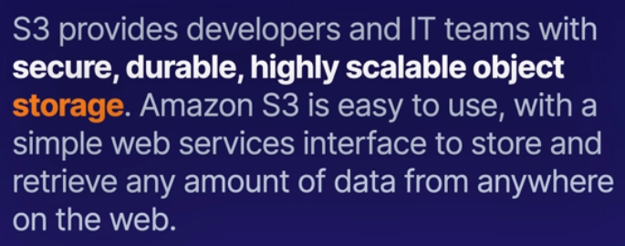

* Store flat objects and static files – pictures, videos
* Can’t install operating system/database on S3

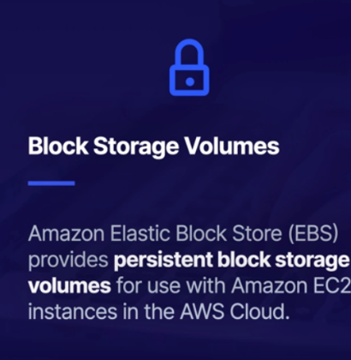

* Virtual hard disk in the cloud; can install operating systems and databases

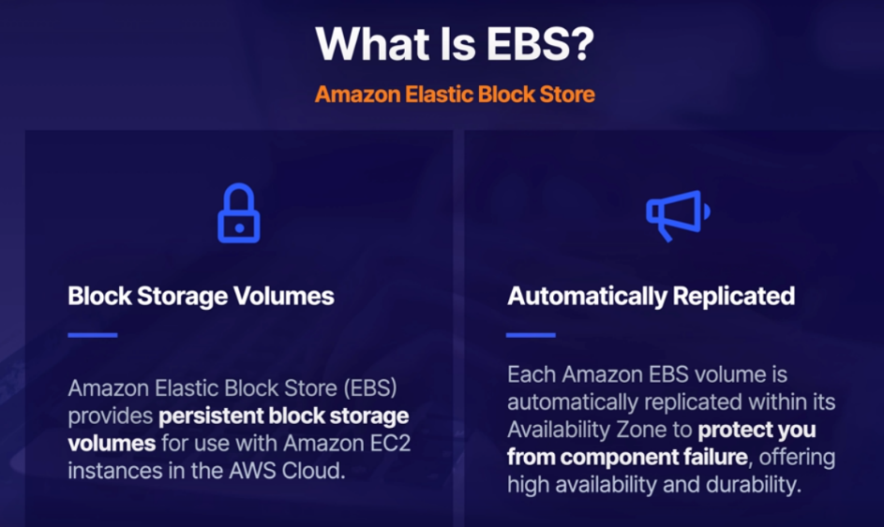

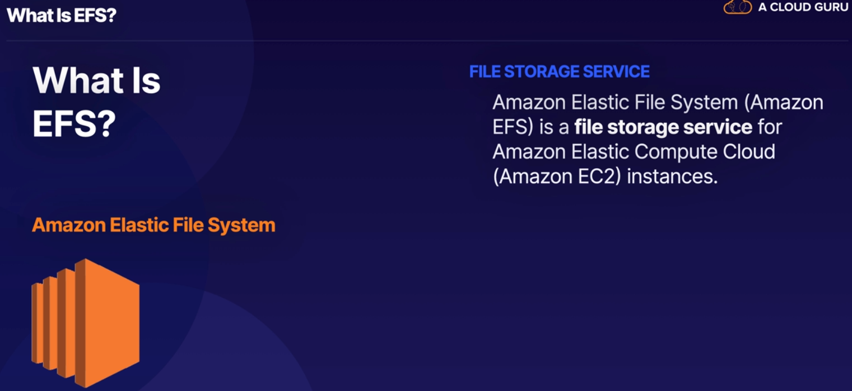

* Content management system, file storage
* Resizes itself – great for content management
* Multiple EC2 instances

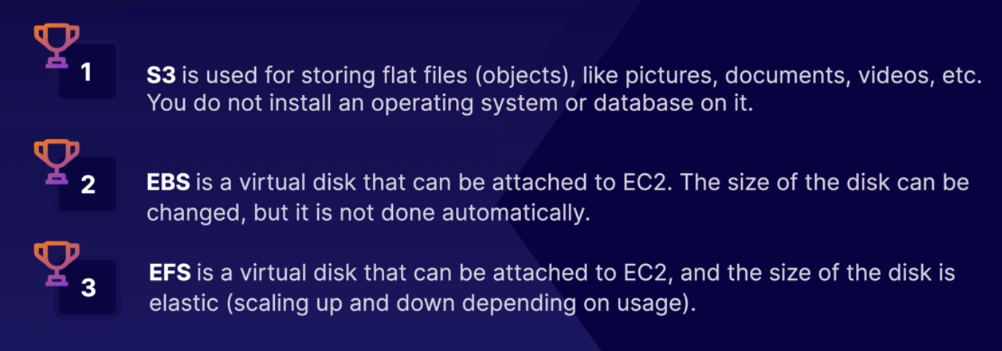

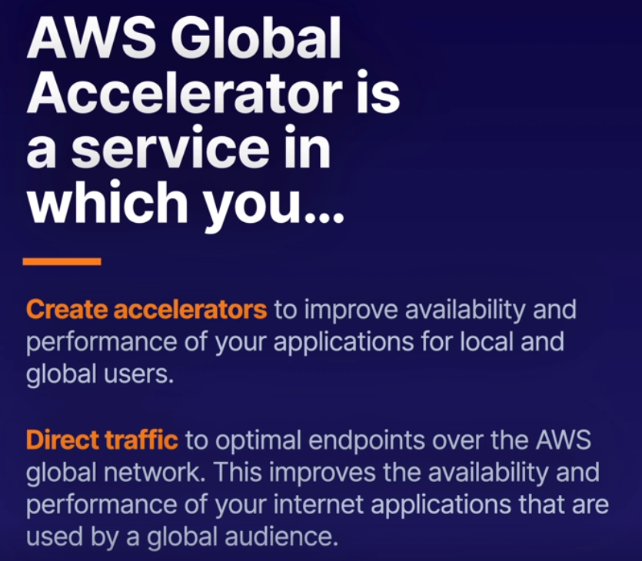

* Accelerating traffic to your applications

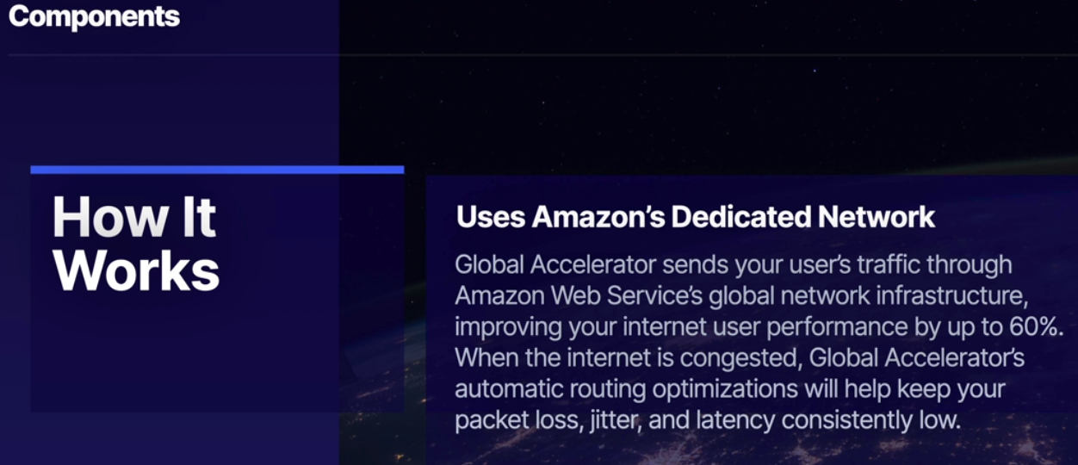

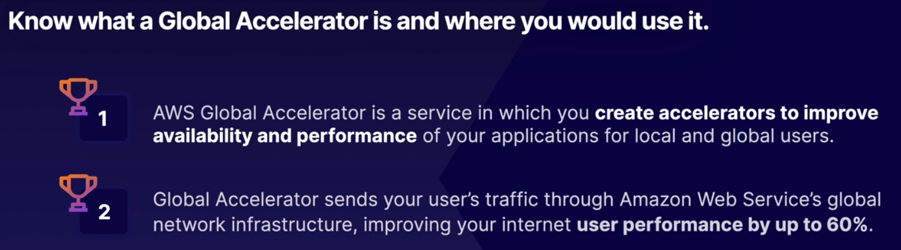

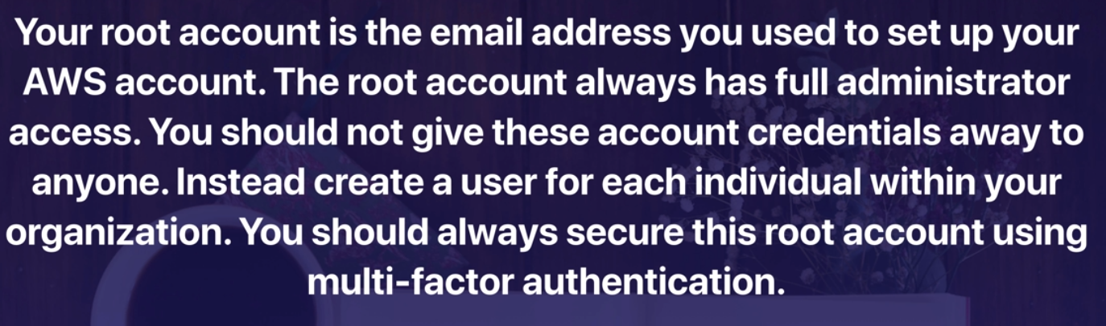

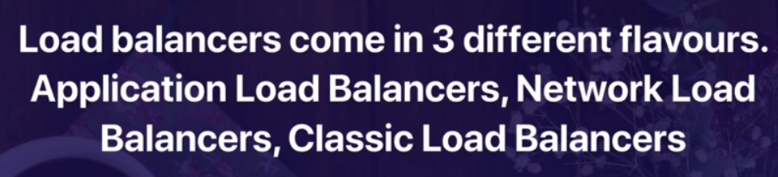* Application Load Balancer – Layer 7 -> make intelligent decisions

* Network Load Blancer – extreme performance/ static IP Addresses

*Classic Load Balancers – old school; test and development to keep costs low -> will be phased out probably

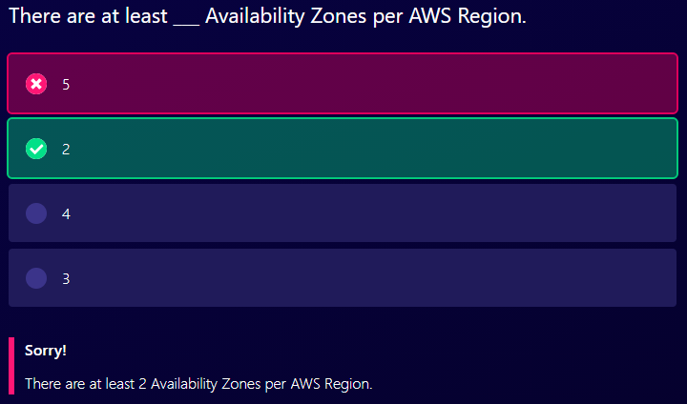

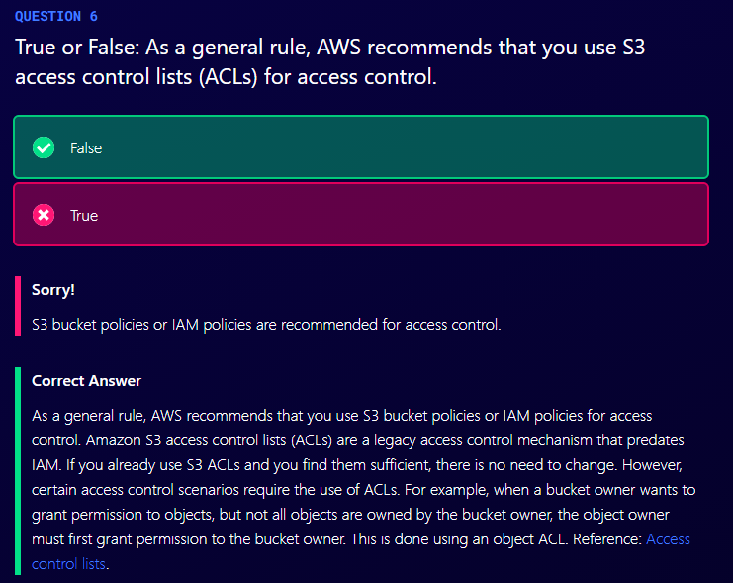

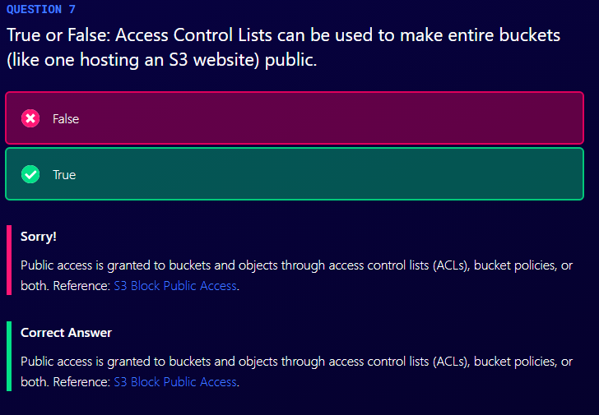

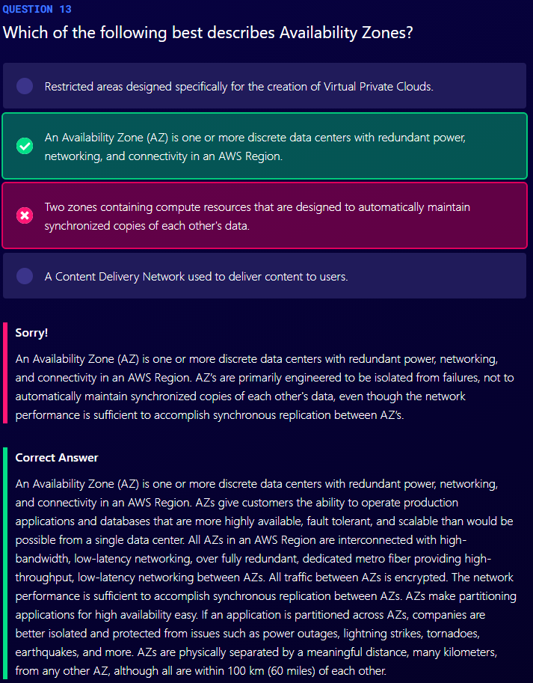

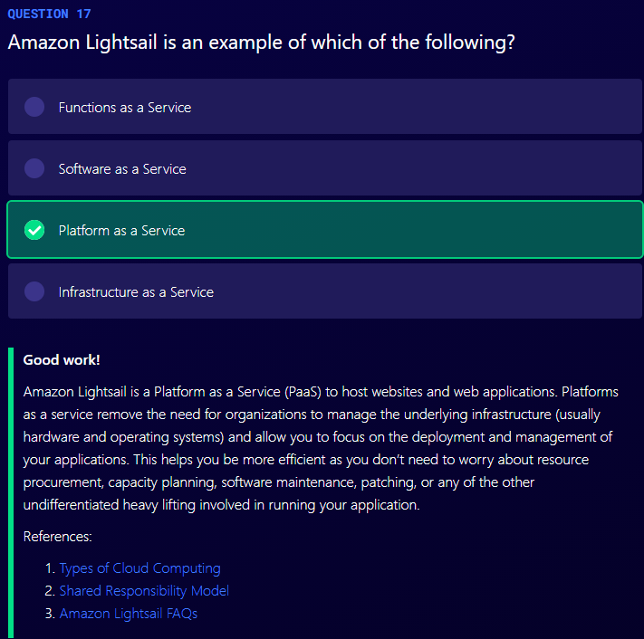

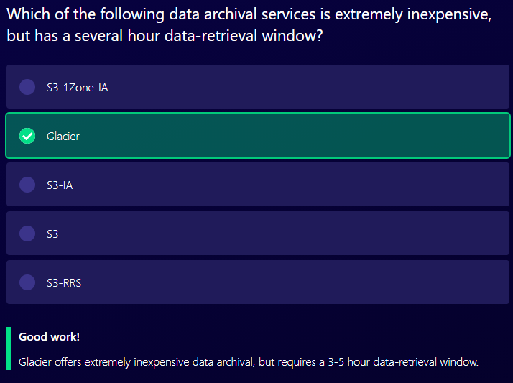

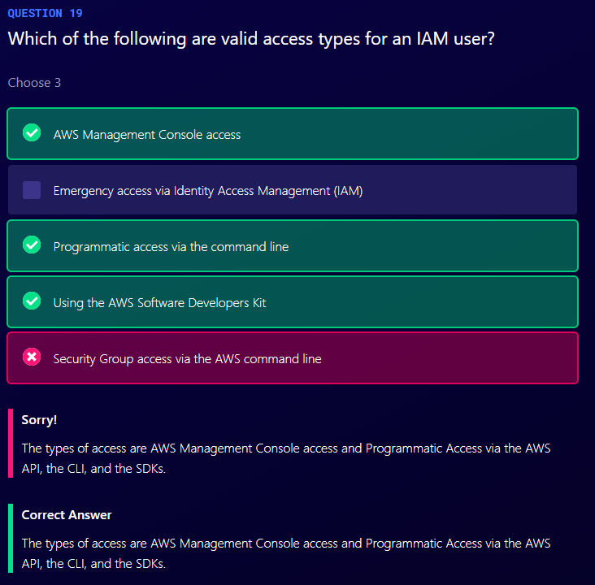

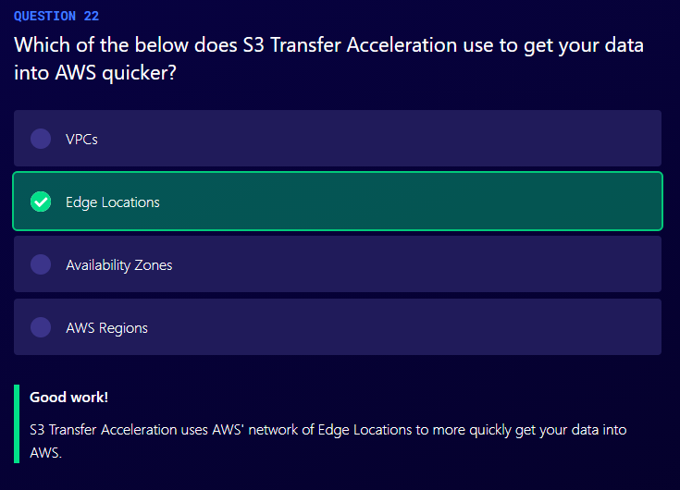

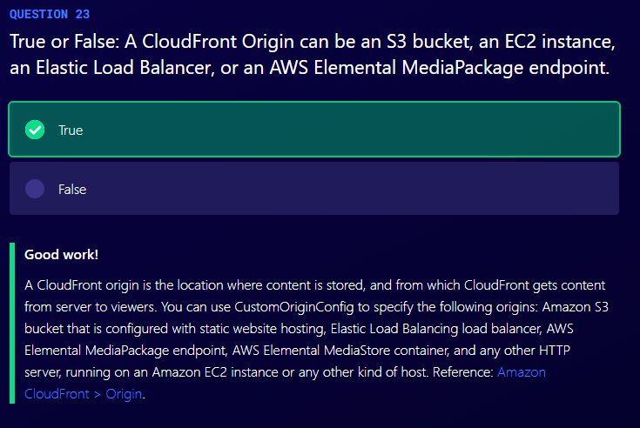

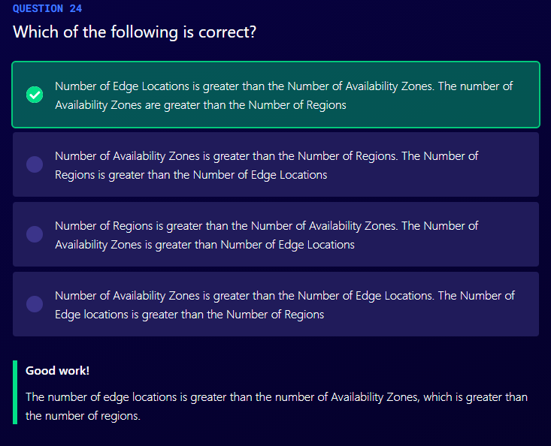

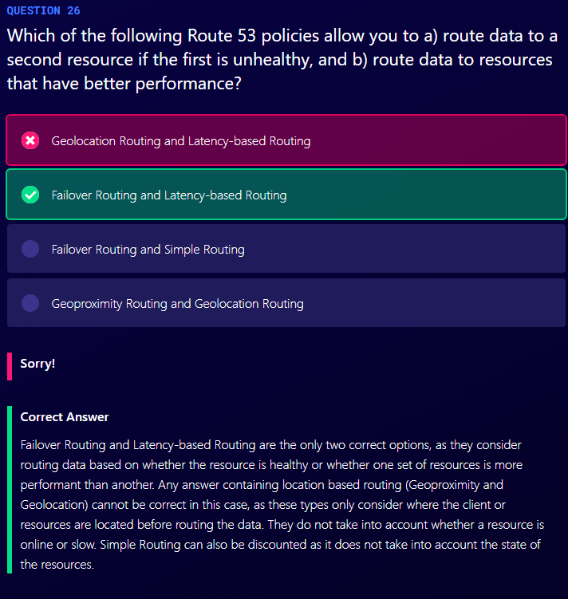

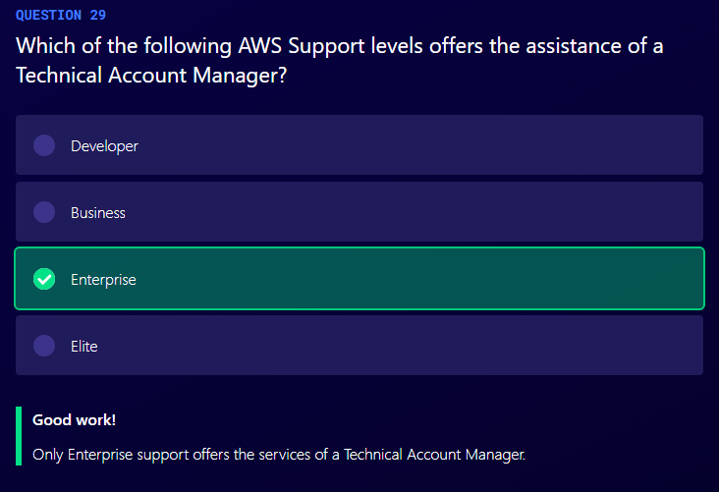

**Chapter 3: Billing & Pricing**

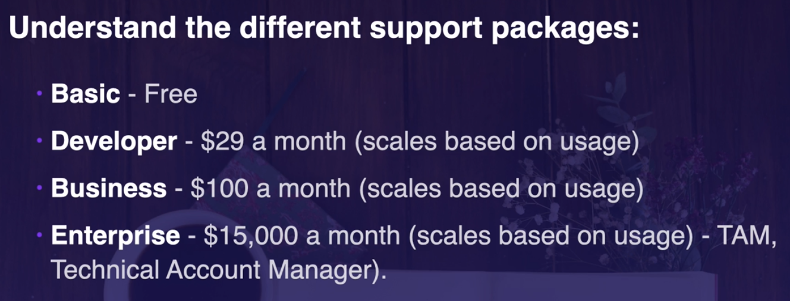

* Enterprise: TAM – provides one to one advisor

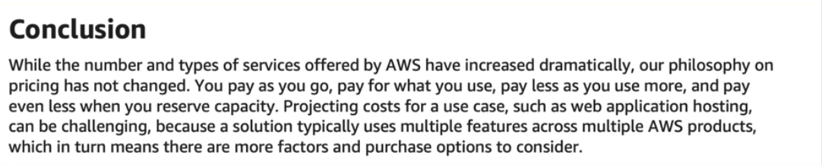

* Capex – Capital Expenditure: pay up front – fixed, sunk cost
* Opex – Operational Expenditure: pay for what you use – utility (electricity, gas, water, etc.) bills
  + Helps for scaling early on

Basic Pricing Policies

1. Pay as you go
2. Pay less when you reserve
3. Pay even less per unit when using more
4. Pay even less as AWS grows
5. Custom pricing

Fundamental Drivers of Cost with AWS:

1. Compute
2. Storage
3. Data Outbound

**Pricing Models Depending on Product**

* On demand
* Dedicated instances
* Spot instances
* Reservations

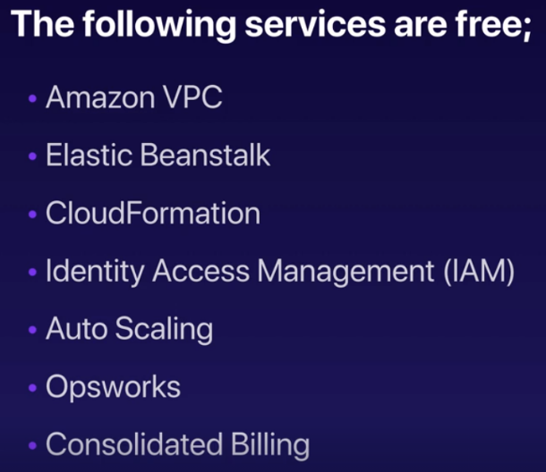

**Determining Price**

1. EC2: clock hours of server time; instance type; pricing model; number of instances; load balancing; detailed monitoring; auto scaling; elastic IP addresses; operating systems and software packages

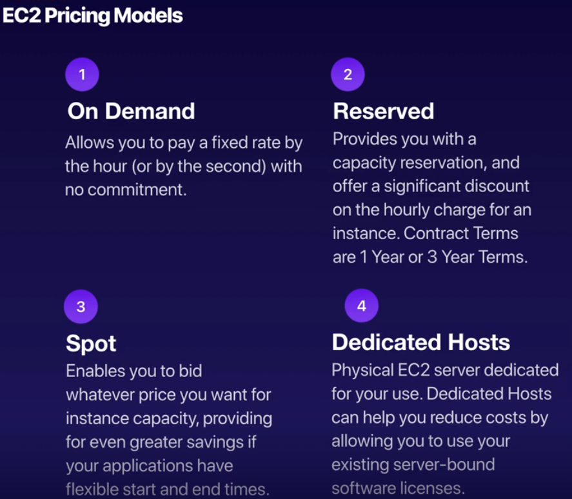

* Use Amazon Elastic Compute Cloud (Amazon EC2) reserved instances to reserve capacity and receive a discount on your instance usage compared to running on-demand instances

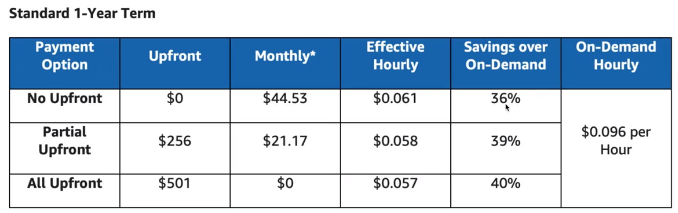

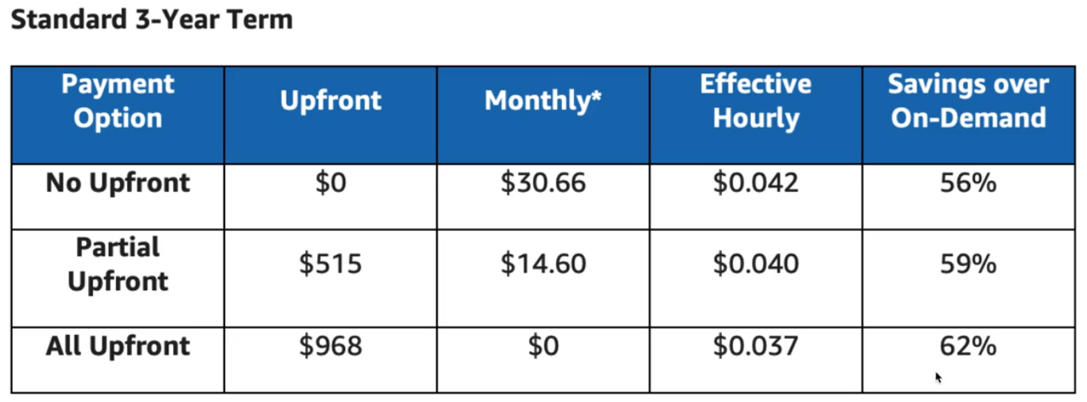

* Lambda = serverless way to do compute – used for Alexa (under the hood); S3 is also serverless

**Price Determination for Lambda**

1. Request Pricing – Free Tier: 1 million requests per month; after 1 million requests: $0.20

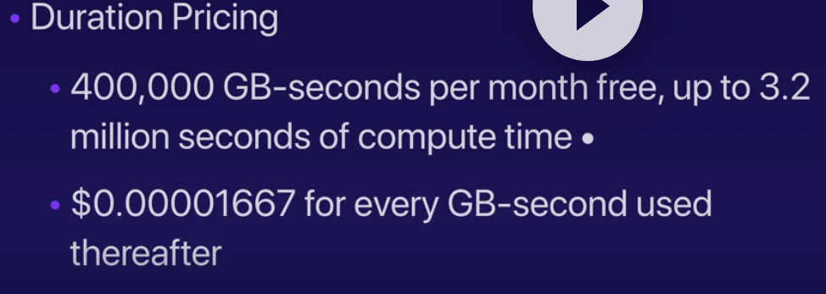

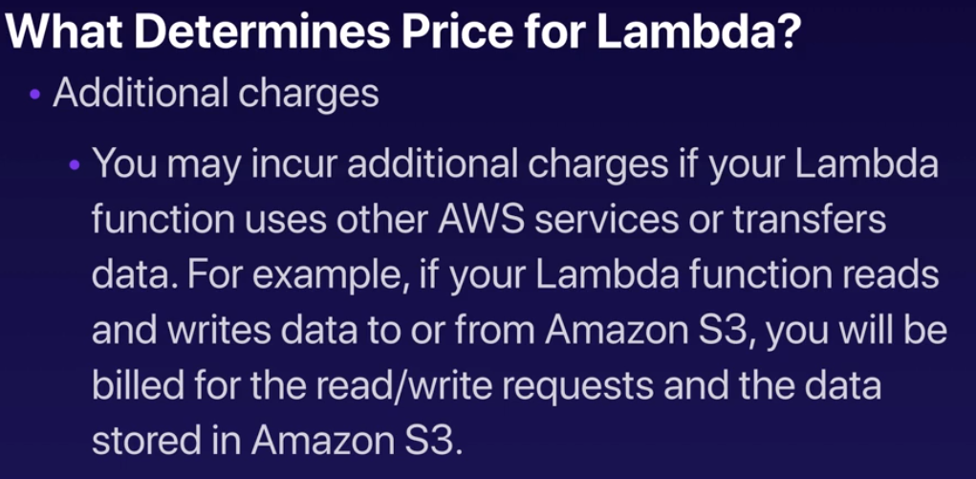

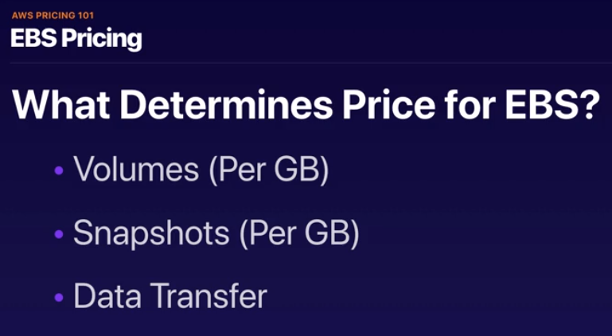

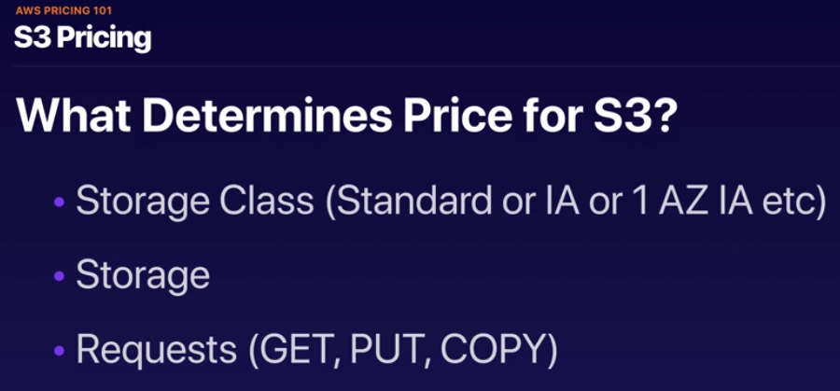

* Data Transfer as well

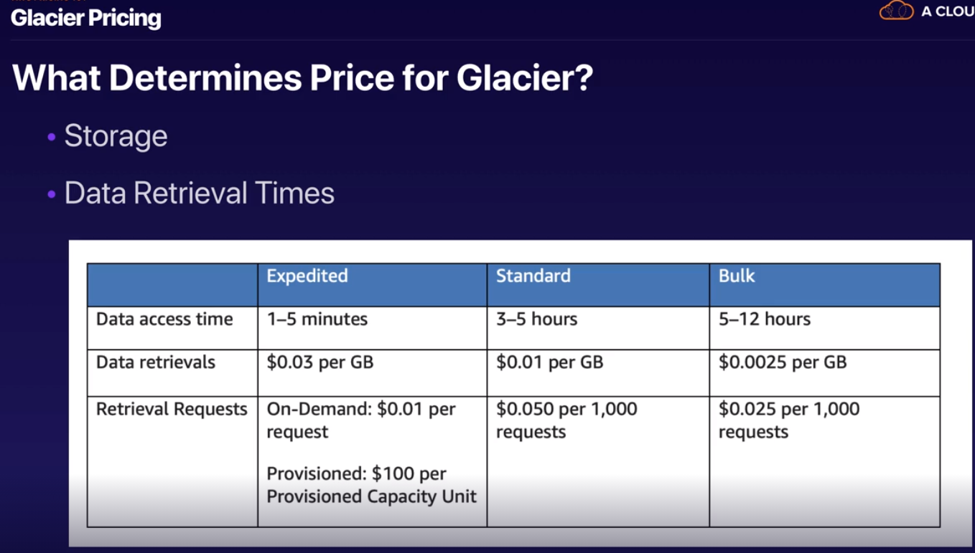

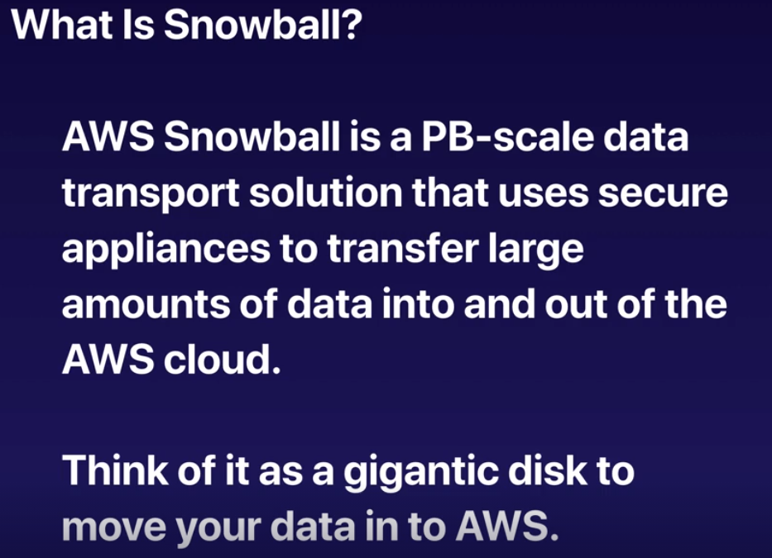

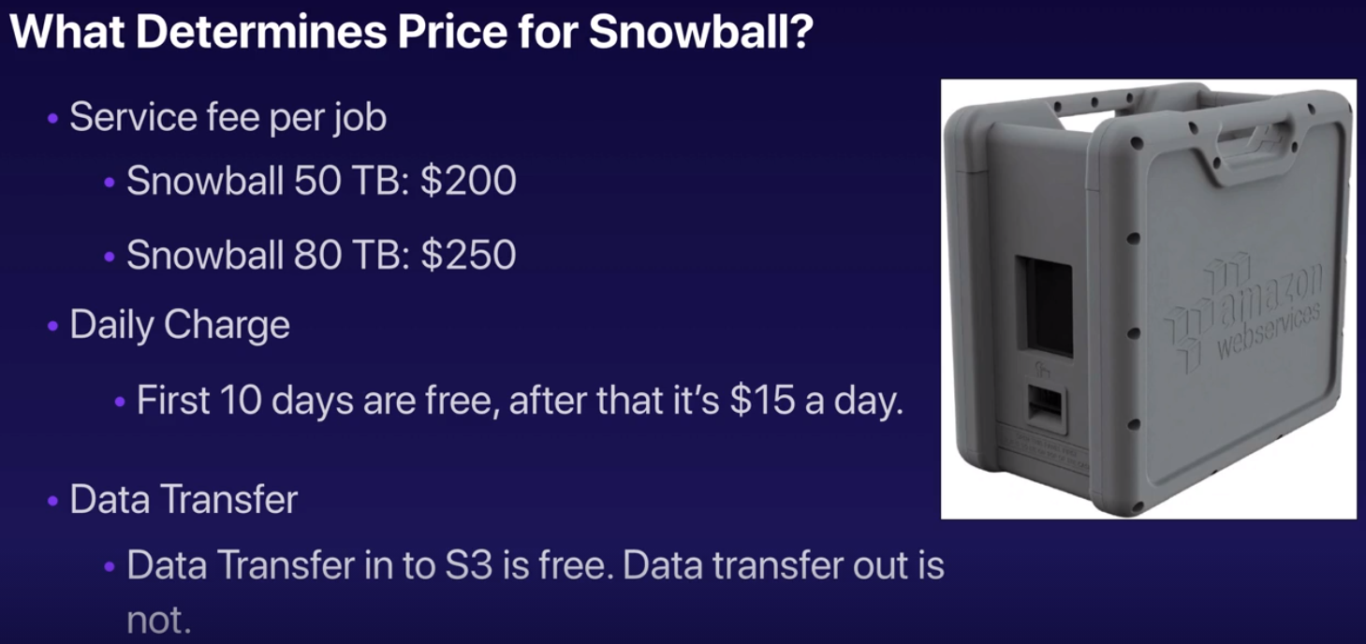

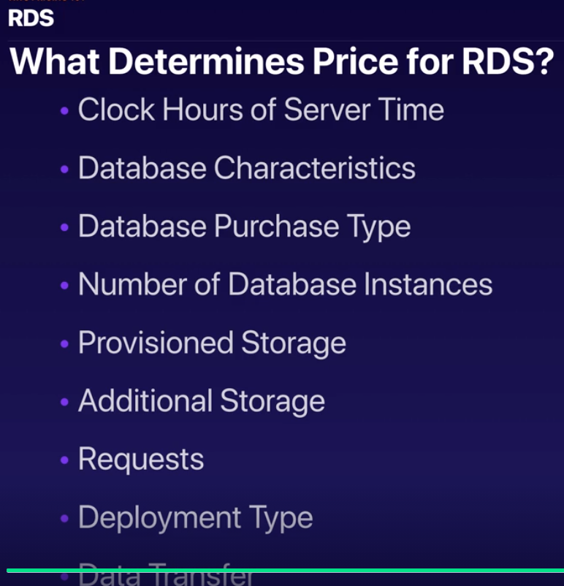

* Data Transfer

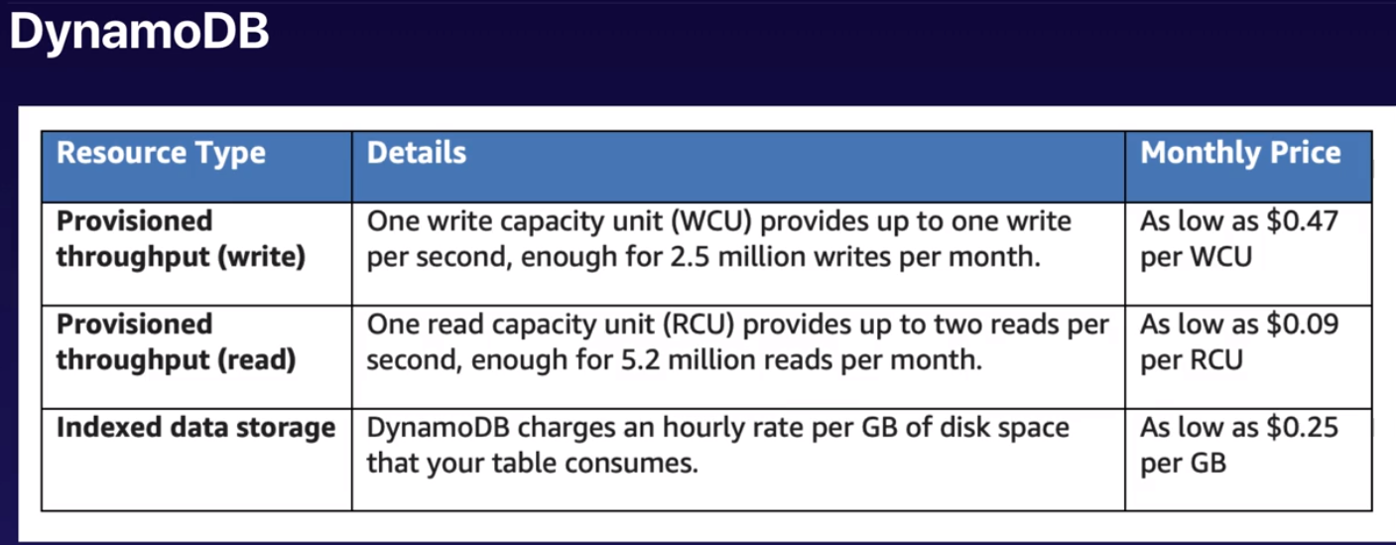

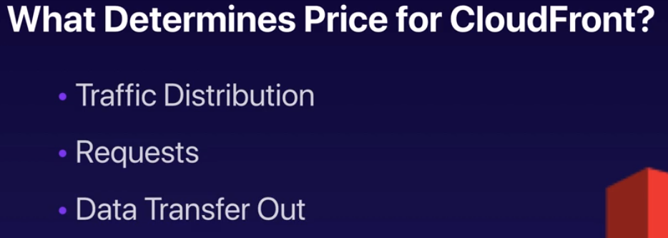

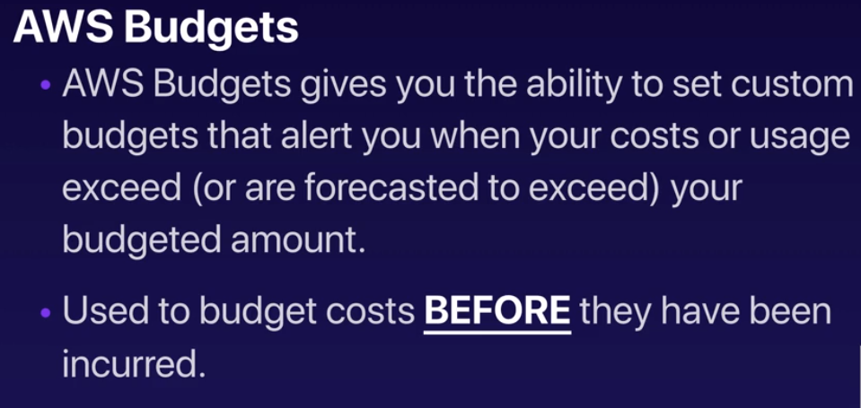

* Budget = Before

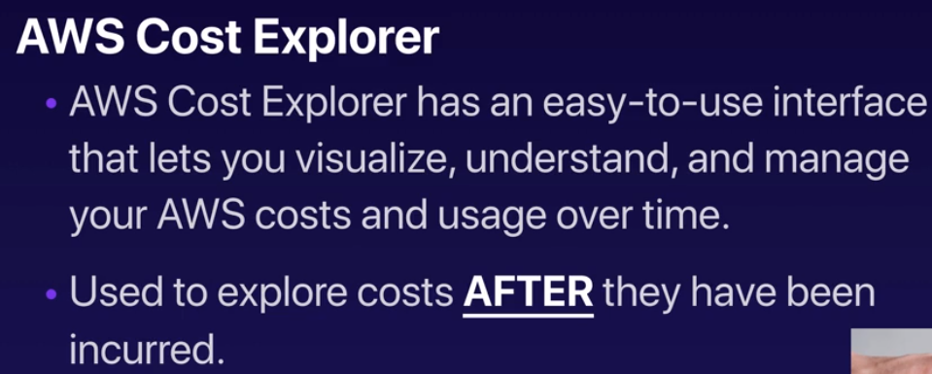

**Support Plans**

